
BEAU-ROC MODEL MPLD - DUMP BODY SPECIFICATIONS

DUMP BODY SPECIFICATIONS:

GENERAL:
Each bidder must indicate on the following items whether their bid is in compliance or not with the stated specifications. Exceptions to the bid must be detailed on a separate written sheet using company letterhead. Bidder must supply literature of the model being bid. Successful bidder must consult with the supervisor on specifications before fabricating the body(ies).

MAKE & MODEL:

BEAU-ROC MPLD (Multi-Purpose, Light Duty)
YES____ NO____

COMPLETION:

The unit(s) must be completed and delivered within ??? weeks after receipt of chassis.
YES____ NO____

DUMP BODY DIMENSIONS:
YES____ NO____
Length: ???' (Options include 10’ to 18' long, usually in 6" increments but 1" increments are acceptable as well)
YES____ NO____
Floor Width: Minimum 87" (no exceptions)
YES____ NO____
Exterior Body Width: Shall not exceed 96” (no exceptions)
YES____ NO____
Side Height: ???" (Options include 42", 48", 54” & 60”)
YES____ NO____
Tailgate Height: ???" (Options include 16” (quick release drop-down), 32”, 42”, 48”, 54” & 60” – Standard is Tailgate at same height as side height)
YES____ NO____
Cabshield: ???" (Options include 12" to 48" in 6" increments)

DUMP BODY MATERIALS:

Floor: ???
YES____ NO____
(Please choose one of the following:
(Standard Floor Material)
Minimum 3/16" 44W (44,000 psi yield strength & 80,000 psi tensile strength)

(Optional)
Minimum 1/4" AR225 (65,000 psi yield strength & 105,000 psi tensile strength)

Minimum 5/32" Hardox 450 (no exceptions) (180,000 psi yield strength & 215,000 psi tensile strength)

Minimum 7 gauge Hardox 450 (no exceptions) (180,000 psi yield strength & 215,000 psi tensile strength)

1/4" Hardox 450 (no exceptions) (180,000 psi yield strength & 215,000 psi tensile strength))

Front: Minimum 10 gauge A36 steel (36,000 psi yield strength & 70,000 psi tensile strength)
YES____ NO____

Sides: Minimum 10 gauge A36 steel (36,000 psi yield strength & 70,000 psi tensile strength)
YES____ NO____

Tailgate: Minimum 10 gauge A36 steel (36,000 psi yield strength & 70,000 psi tensile strength
YES____ NO____

BODY UNDERSTRUCTURE DESIGN

Body shall be cross-memberless. Cross-member understructure not acceptable, no exceptions.
YES____ NO____

Longitudinals shall be C-channel structural steel with a formed flared support flange. Support flange must have a minimum 1 3/4" returnto support the floor with as wide a span as possible. Longitudinal shall have a minimum bottom surface span of 2 1/4" wide.
YES____ NO____
YES____ NO____
All seams shall be 100% fully welded.
YES____ NO____
Longitudinal Height: ???" (8", 10" & 12”)
FLOOR DESIGN:

Floor sheet shall be formed such that the floor bends up at 57 degrees to join the side sheet forming a knee brace. The floor shall have a minimum flat section width of 77’. All seams shall be 100% fully welded.
YES____ NO____

FRONT DESIGN:
YES____ NO____
Front Bulkhead shall be of one-piece flat panel design.

Front shall be capped at the top with a 4”x3”x3/16” structural tube that runs the full width of the front sheet.
YES____ NO____

CABSHIELD DESIGN:

Cabshield shall be constructed of a minimum of 10 gauge steel. Cabshield must be 100% fully welded (stitch welding not acceptable).
YES____ NO____

SIDES DESIGN:

Fully formed, single piece side with two press-in horizontal V-braces to increase rigidity.
YES____ NO____

Lower rub rail shall be formed and integral to the side sheet (weld-on rub rails are not acceptable), dirt shedding and joined to the floor. It shall have an angle of 40 degrees and shall have a 90 degree end face of 3" high (rub rails that finish in a point or rounded edge are not acceptable).
YES____ NO____
YES____ NO____
4"x3"x3/16” top rail is must be a structural steel HSS tubing. Formed top rails are not acceptable.

Notes:
- "Weld-on horizontal bracing is not acceptable due to inferior design, more weight, and decreased flexibility of the side"
- "Flat sided designs are not acceptable due to inferior rigidity and stability of the side plate"

Rear posts shall be full depth, one-piece construction and fabricated out of a minimum 3/16" steel.
YES____ NO____

(Optional)
Passenger side shall be constructed with a 52” side access door at 14” from the front of the body.
YES____ NO____

Side door shall be constructed of a minimum 10 gauge A36 steel (36,000 psi yield strength & 70,000 psi tensile strength). Side door frame to be constructed with 4”x3”x3/16” structural HSS tubing.
YES____ NO____

Side door shall be constructed with two press-in horizontal V-braces and integral dirt shedding rub rail.
YES____ NO____
YES____ NO____
Side door shall be hinged to rotate open towards the back of the body.

Locking mechanism must pivot and lock quickly for ease of operation. A safety chain must be incorporated as secondary safety mechanism to ensure that the lock does not open accidentally.

The locking handle and mechanism shall be incorporated in a hinged steel flap. The steel flap must be designed to prevent leakage at the hinge pivot point and also serve to keep the door firmly in place when closed.
YES____ NO____
YES____ NO____
All body seams must be 100% fully welded.

TAILGATE DESIGN:
(Please choose one of the following):
1.
Tailgate shall be of manual side opening design (“Barn Door Style”). Tailgate wear surface shall be a single piece, fully formed, with two press-in horizontal V-braces to increase rigidity. Flat panel designs are unacceptable due to inferior rigidity and stability. Outer side bracing shall be 3”x1”x1/8” structural HSS tubing.
YES____ NO____
YES____ NO____
Side opening hardware shall consist of two (for 42” & 48” high T/Gs) or three (for 54” & 60” T/Gs) side opening hinges with 1” diameter hinge pins. The pins shall be inserted in two bushings complete with castle nut.
YES____ NO____
Hinges shall be greasable.

Tailgate latch shall be equipped with an ergonomic handle and must have a spring-loaded return for safety.
YES____ NO____

2.
(For Tailgates of all heights except 16”)
Tailgate shall be of double manual side opening design (“Double Barn Door Style”). Tailgate wear surfaces shall be a single piece, fully formed, with two (2x) pressed-in horizontal V-braces to increase rigidity. Flat panel designs are unacceptable due to inferior rigidity and stability. Tailgate outer frame shall consist of a single, dirt shedding, formed 3/16” thick upper and lower brace. Outer side bracing shall be 4”x3”x3/16” structural HSS tubing.
YES____ NO____
YES____ NO____
Tailgate shall consist of two center bottom-mounted, spring-loaded latches plus one safety spring-loaded latch mounted center and 18” up from the bottom of the door. Tailgate consists of an inner overlap plate to prevent debris and material from spilling out.

3.
(For 16” drop down tailgate with optional double upper manual side opening doors)
Tailgate shall be of quick-release, drop down design and must have the ability to lay flat so that the surface of the tailgate is flush with the surface of the floor. Mechanism consists of one central pivot handle mounted on a bearing with greasable pins that are activated simultaneously.
YES____ NO____

(Optional – available with 16” only) – Tailgate shall have a mesh (expanded metal) upper double barn door. Mesh frame shall be designed with a 2”x2”x3/16” frame and shall be locked in place by a spring latch.
YES____ NO____
YES____ NO____
Sufficient length of 3/8" Grade 70 chains for the full function of the tailgate.

All tailgate hinge linkage must have grease zerks at all pivot points.
YES____ NO____
YES____ NO____
All body seams must be 100% fully welded.

TAILGATE LOCKING MECHANISM & REAR BUMPER DESIGN:

Latch fingers shall be a minimum 5/8" thick steel that seat into a latch holder of a minimum thickness of 3/8" steel.
YES____ NO____
YES____ NO____
Locking mechanism pins shall be a minimum 1.25" in diameter.
YES____ NO____
Entire mechanism shall be mounted to a minimum 3/16”, 80,000 psi yield strength high tensile steel bumper.

The bumper shall be full width and shall extend and span the width under the rear posts (no exceptions). The bumper shall be fully welded to the floor and full depth rear posts to form a high strength structurally sound unit.
YES____ NO____

REAR POST DESIGN:

Rear posts shall be full depth, one-piece construction and fabricated out of a minimum of 3/16" 44W steel.
YES____ NO____

ROOF DESIGN (Optional):
YES____ NO____
Dump body shall be equipped with a removable roof.
YES____ NO____
Roof shall be ??” long by 12” high.
YES____ NO____
Roof shall be made of ?? (one or two) section(s).
YES____ NO____
Roof shall be constructed of 10 gauge A-36 steel (36,000 psi yield strength & 70,000 psi tensile strength).
YES____ NO____
Roof shall be designed to be fastened with multiple Buyers TGL3410ST Safety Twist Lock.
YES____ NO____
Roof frame shall be a constructed of 3”x1”x1/8” structural HSS tubing.

Roof must design must be made with structural bends to increase structural rigidity and that also allows for proper water drainage. (Refer to the following 3D CAD design pictorial)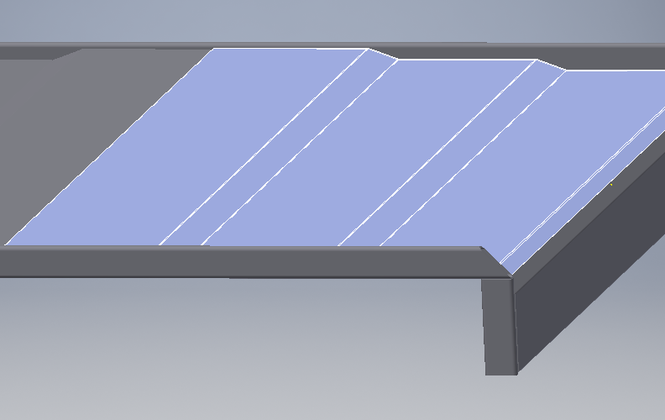
YES____ NO____
UNDERBODY HOIST:

Hoist Design Type: Dealer to add details…
YES____ NO____
Hoist Brand: Dealer to add details…
YES____ NO____
Hoist Series: Dealer to add details…
YES____ NO____
Hoist Diameter: Dealer to add details…
YES____ NO____
Hoist Stroke: Dealer to add details…
YES____ NO____
Hoist Warranty: Dealer to add details…

REAR HINGE ASSEMBLY: (Must choose one of the following or add your own hinge info)

24 ton rear hinge assembly shall be constructed of 4"x4"x5/16" structural angle with 1 7/8" x 5 ¼” tempered steel hinge pins and 2" thick x 7 7/8” tempered steel hinge blocks/pivots. Fixed hinge blocks shall be 1” thick x 4 ¼”. Bearing points shall be greasable.
YES____ NO____

35-45 ton rear hinge assembly shall be constructed of 4"x4"x3/8" structural angle with 2 1/4" x 7 1/8” tempered steel hinge pins and 3" thick x 7 5/8” tempered steel hinge blocks/pivots. Fixed hinge blocks shall be 1 ½” thick x 4”. Bearing points shall be greasable.
YES____ NO____
YES____ NO____
Pivot blocks are adjustable with a bolt on cap for easy pin replacement.

HYDRAULICS & CONTROLS:
YES____ NO____
Dealer to add info...

LIGHTING & ELECTRICAL:

Dealer to add info...
YES____ NO____

BODY PREPARATION & PRIMER:
YES____ NO____
Body shall be sandblasted.

Body shall be primed with a 2-part epoxy primer at a minimum thickness of 4mil(No Exceptions)
YES____ NO____

Primer salt spray resistance must be a minimum of 1,500 hours (No Exceptions - primer manufacturer's literature showing the required minimum salt spray resistance must be submitted with the bid).
YES____ NO____

PAINT:

Dealer to add info...
YES____ NO____

WELDING:

All body welds shall be 100% full and continuous.
YES____ NO____

DUMP BODY WARRANTY:
YES____ NO____
Minimum one year parts and labour.

